**Executive Summary**

Through our pentesting we found three known vulnerability that can be exploited by attacker to gain complete control of our server. All business documents and services provided by our company(servers) will be in the hands of attackers. These three vulnerability are found in the wordpress site, the ssh service, and the python sudo privilege for user steven.

The vulnerability that needs to be address immediately would be the Python sudo privilege for user steven. Sudo privilege should never be given to programs/editors/interpreters as it allows that user to get gain root access. For our case it provides a way for the attacker to gain full access by only comprising the user steven.

Wordpress and ssh services are both on old versions of ssh and wordpress. As results services bleed information. Both services can be scanned for username and sequently be password broken via bruteforce.

**Reconnaissance**

**General Reconnaissance**

**We use nmap -T4 -A -v** - reasonable quick, scan the most common TCP ports. It will try to determining the OS type and what services/versions are running.

View our results and we will notice the Host: **192.168.56.102**

1. has ssh(**ssh-2.0-openssh_6.7p1 debian-5+deb8u4**) open
2. Has http services run on server **Apache httpd 2.4.10** (Debian)
3. Has **rpcbind** on port 111

We now either attack the website, or ssh on **192.168.56.102**

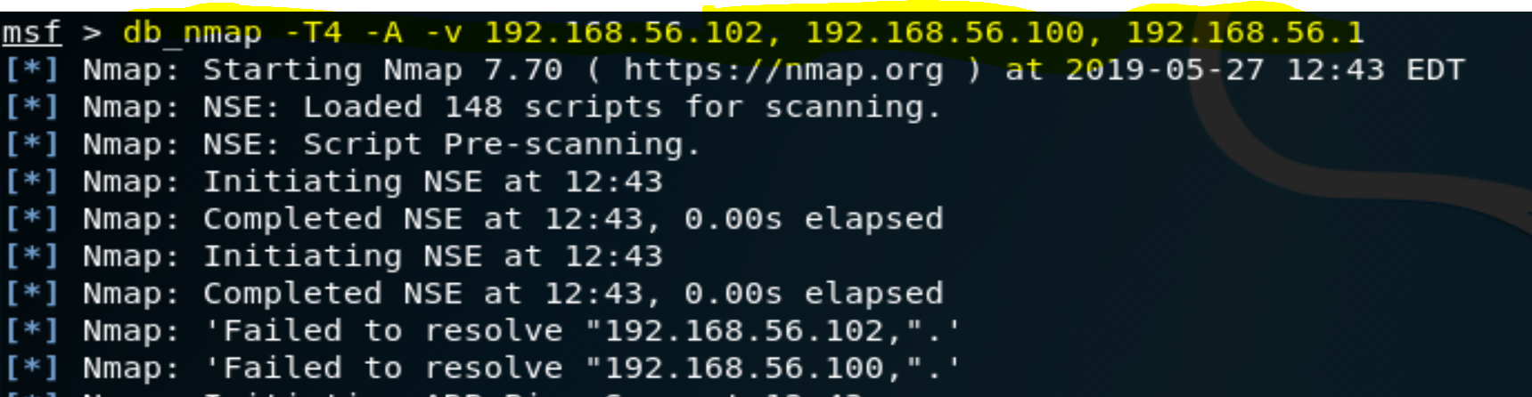

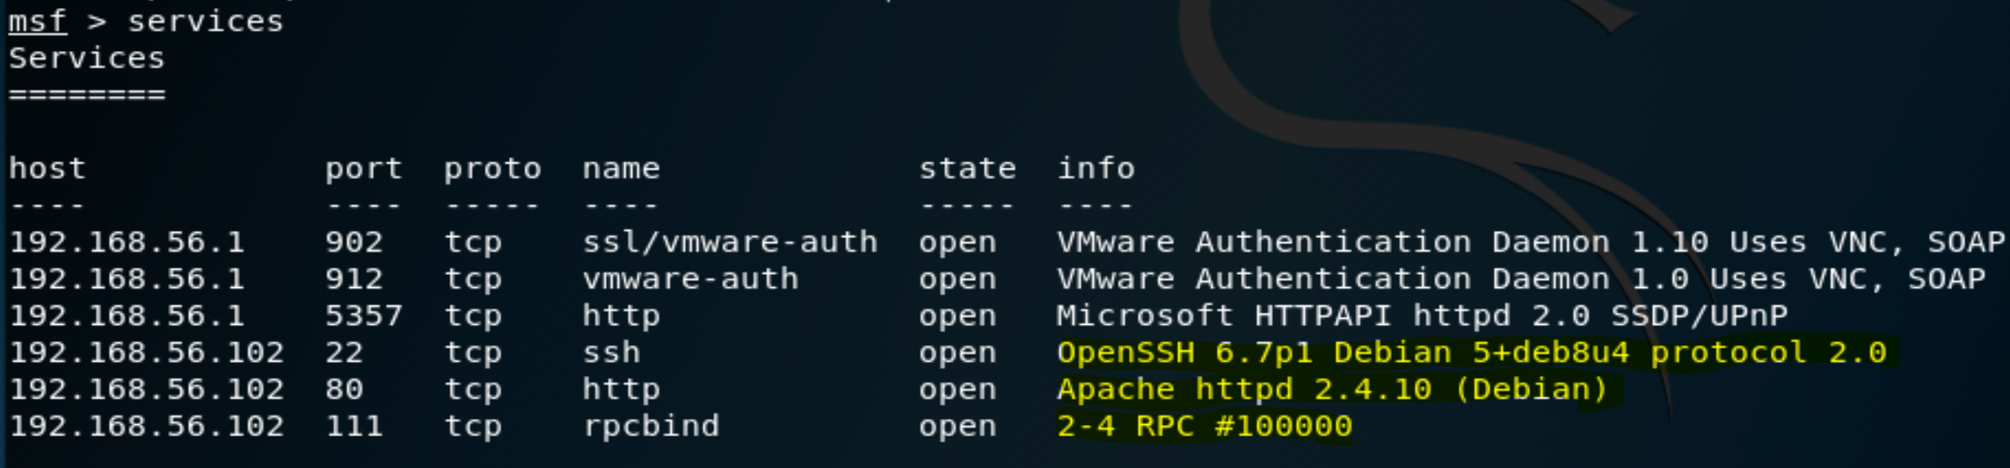

**Enumeration and Vulnerability Analysis**

This section summarizes the most critical vulnerabilities affecting the target network.

*FIll out the table below for your target. Under* ***Vulnerabilities****, include things like: “Exposed Login Server”, “Exposed Web Server”, etc.*

|  |  |  |  |
| --- | --- | --- | --- |
| **IP Address** | **Operating System** | **Vulnerabilities** | **Risk (Low/Med/High)** |
| 192.168.56.102 | Linux Debian 8.11 Jessie | Sudo Python privilege for user steven | HIGH |
| 192.168.56.102 | Linux Debian 8.11 Jessie | -Wordpress versions is outdated  -can be scanned/can be brute force  -mysql login credentials are clear and not hashed, config file should be moved safer location. | MEDIUM |
| 192.168.56.102 | Linux Debian 8.11 Jessie | SSH version outdated, can be scanned, can be brute forced | MEDIUM |
|  |  |  |  |

**Web Server Analysis**

**1.** From our nmap scan we know that **192.168.56.102** has a website. We can use any programs to crawl the website and find interesting things. For our case we used auxiliary/crawler/msfcrawler module in metasploit to crawl the website. We find that this web server is running wordpress

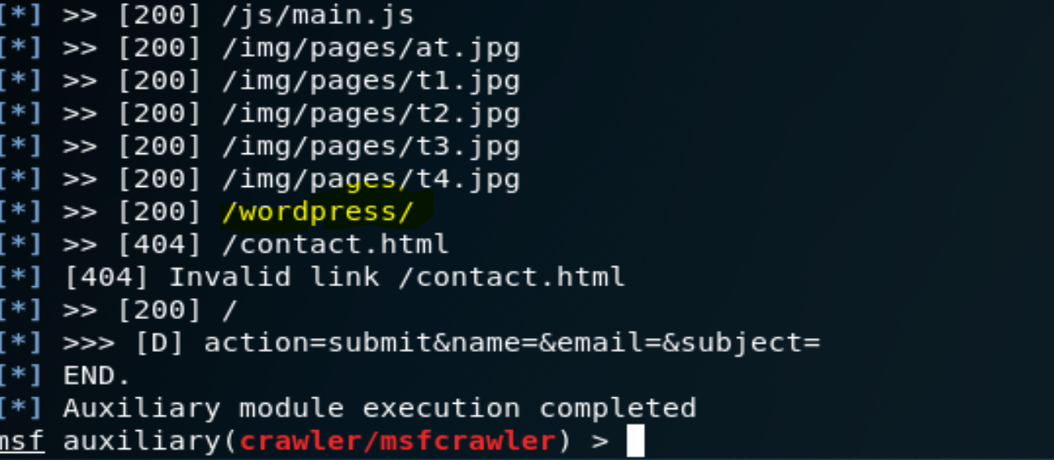

2. Wordpress is known for being very vulnerable. Hence we will use wpscan(wordpress vulnerability scanner) to enumerate any information we can. Wpscan returns to us login page, and two possible users(**steven, and michael**)

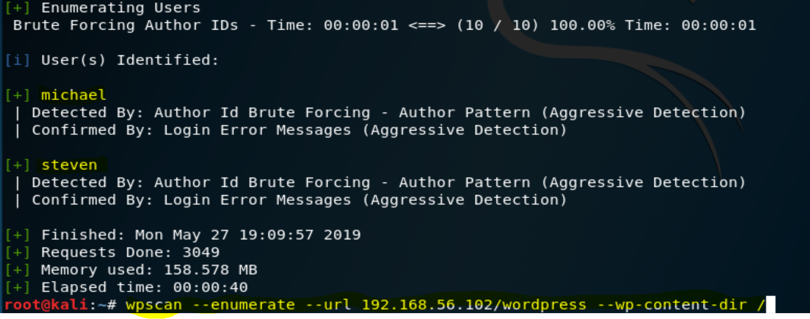

3. Now knowing the login user name, we can attempt to brute the wordpress site using scanner/http/wordpress_login_enum module in metasploit. We were unable to brute force login for use michael, but we credentials for steven(**steven:pink84 --** the also uses the same credentials for ssh, credentials should not be the same across different services)

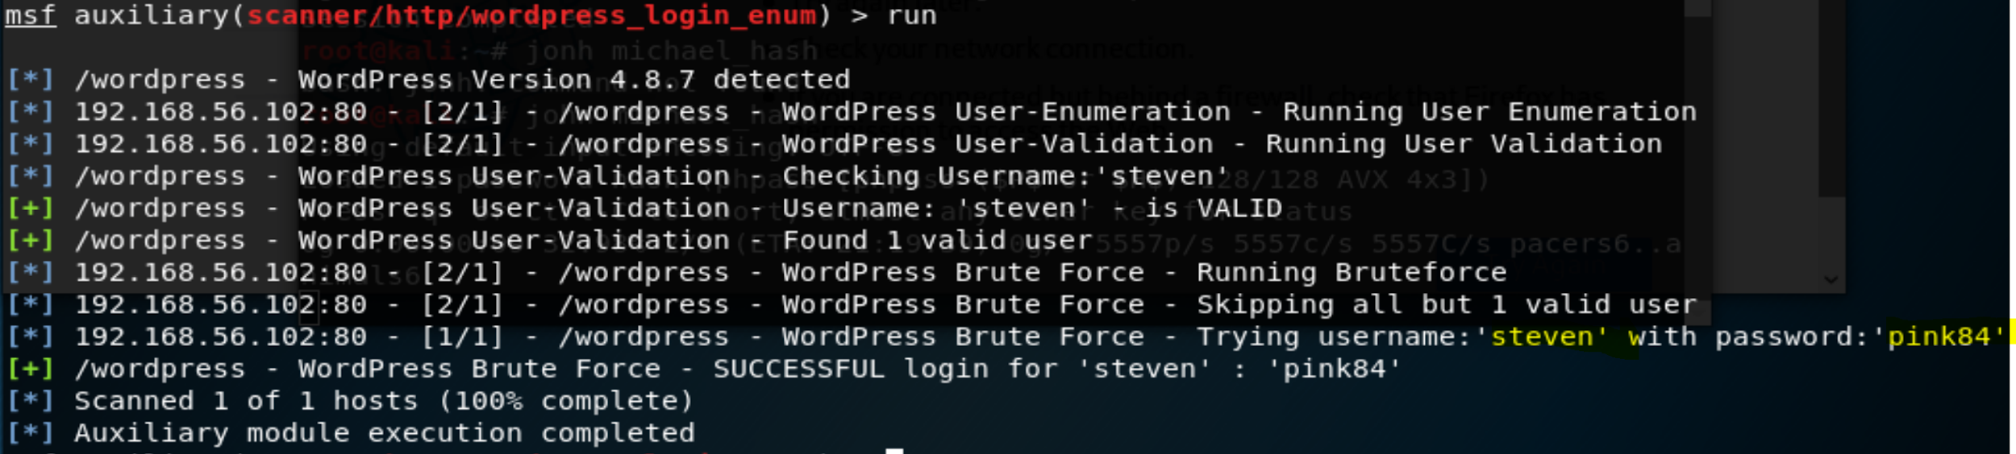

4. We can now login into wordpress site with steven:pink84 and edit the site as we like

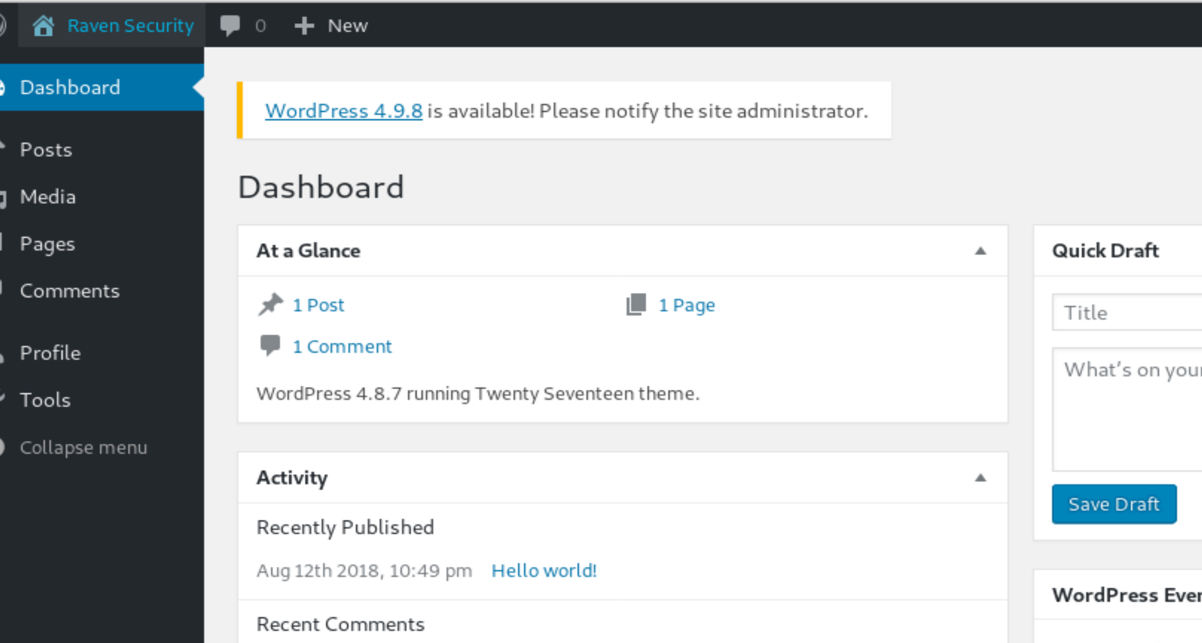

**Network Analysis**

From our nmap scan results we know that the host **192.168.56.102** has port 22 ssh open for services.



The ssh version that host is using is vulnerable to ssh exploit, specifically it can be brute force and we can enumerate users too. Before we can brute force it will use **auxiliary/scanner/ssh/ssh_enumusers** module in metasploit to see what users are registered to the ssh services. We will use the /usr/share/wordlists/metasploit/common_roots.txt(contains most common users name) with module and check ssh services.

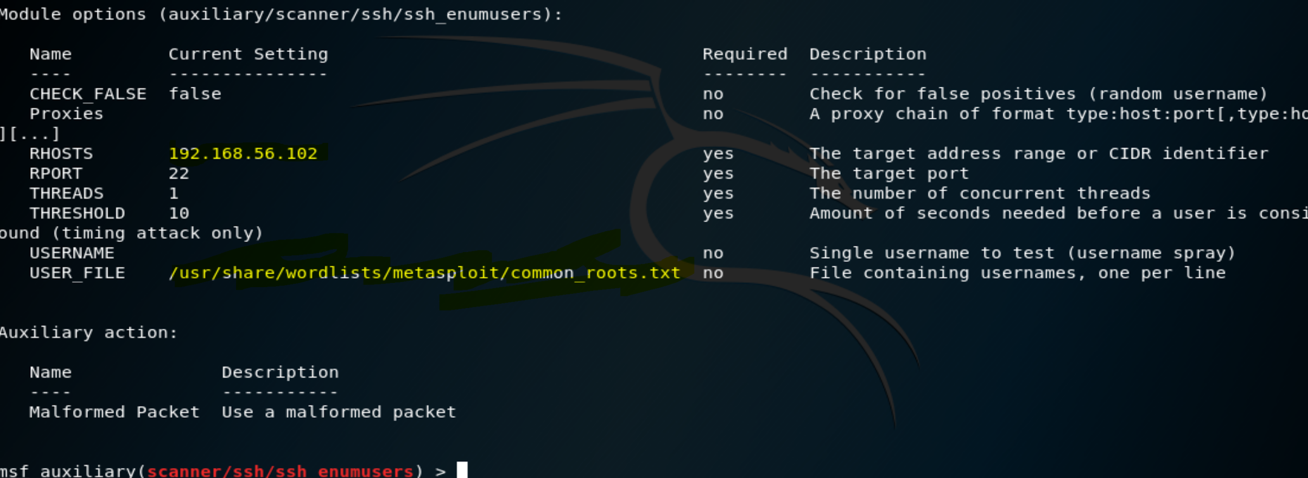

We are in luck we able to get a lot of users registered to the ssh service. But the most interesting one are michael, and steven

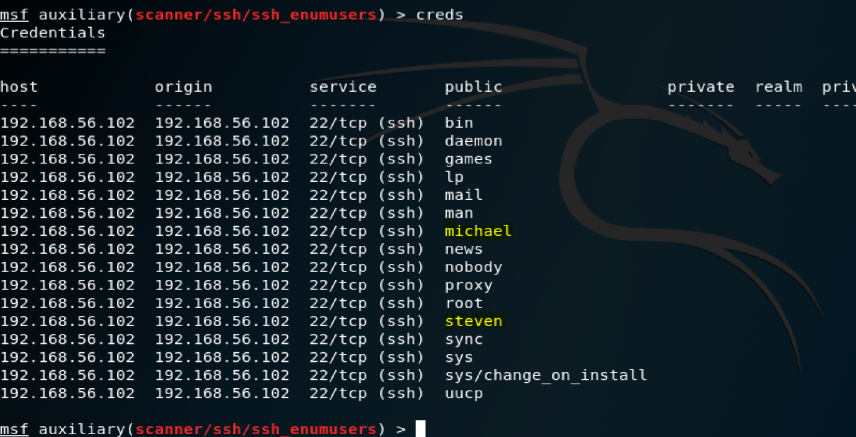

4. Since now have the users(**michael,steven**) we can now brute force the login with metasploit module(**auxiliary/scanner/ssh/ssh_login**). We will attempt brute force using the password list(/usr/share/wordlists/rockyou.txt)

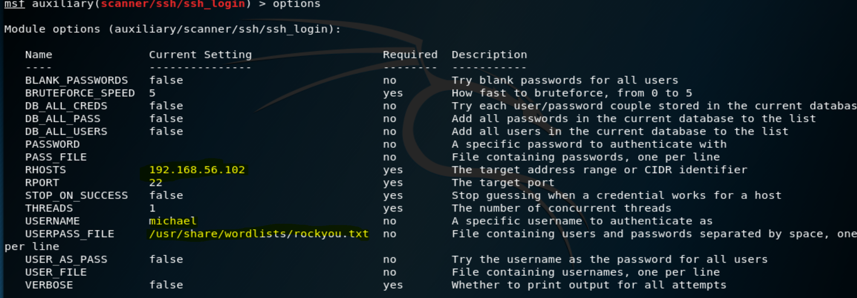

We were able to succeed in brute forcing the ssh login:

**Ssh credentials:**

**Id:michael, pw:michael**

**Id:steven, pw:pink84**

5.Using michael:michael, we can ssh in to **192.168.56.102.** , if we check michael’s privilege, he’s just a regular user no sudo power. We know that **192.168.56.102** has port 80 open and is running a website. If we head to the /var/www and snoop around we will get **flag2.txt**.

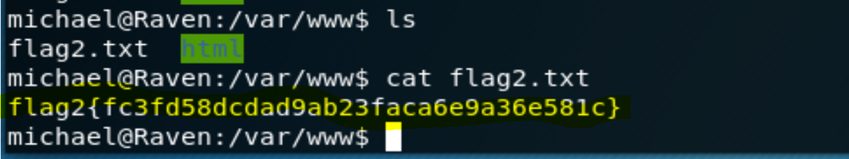

If we further snoop around the web site directory, we see that there is a wordpress website on the server, we will be able to get the login in credentials for the wordpress MySQL database. We find the credentials in the file /**var/www/html/wordpress/wp-config.php**

Db: **wordpress**, user: **root**, password: **R@v3nSecurity**



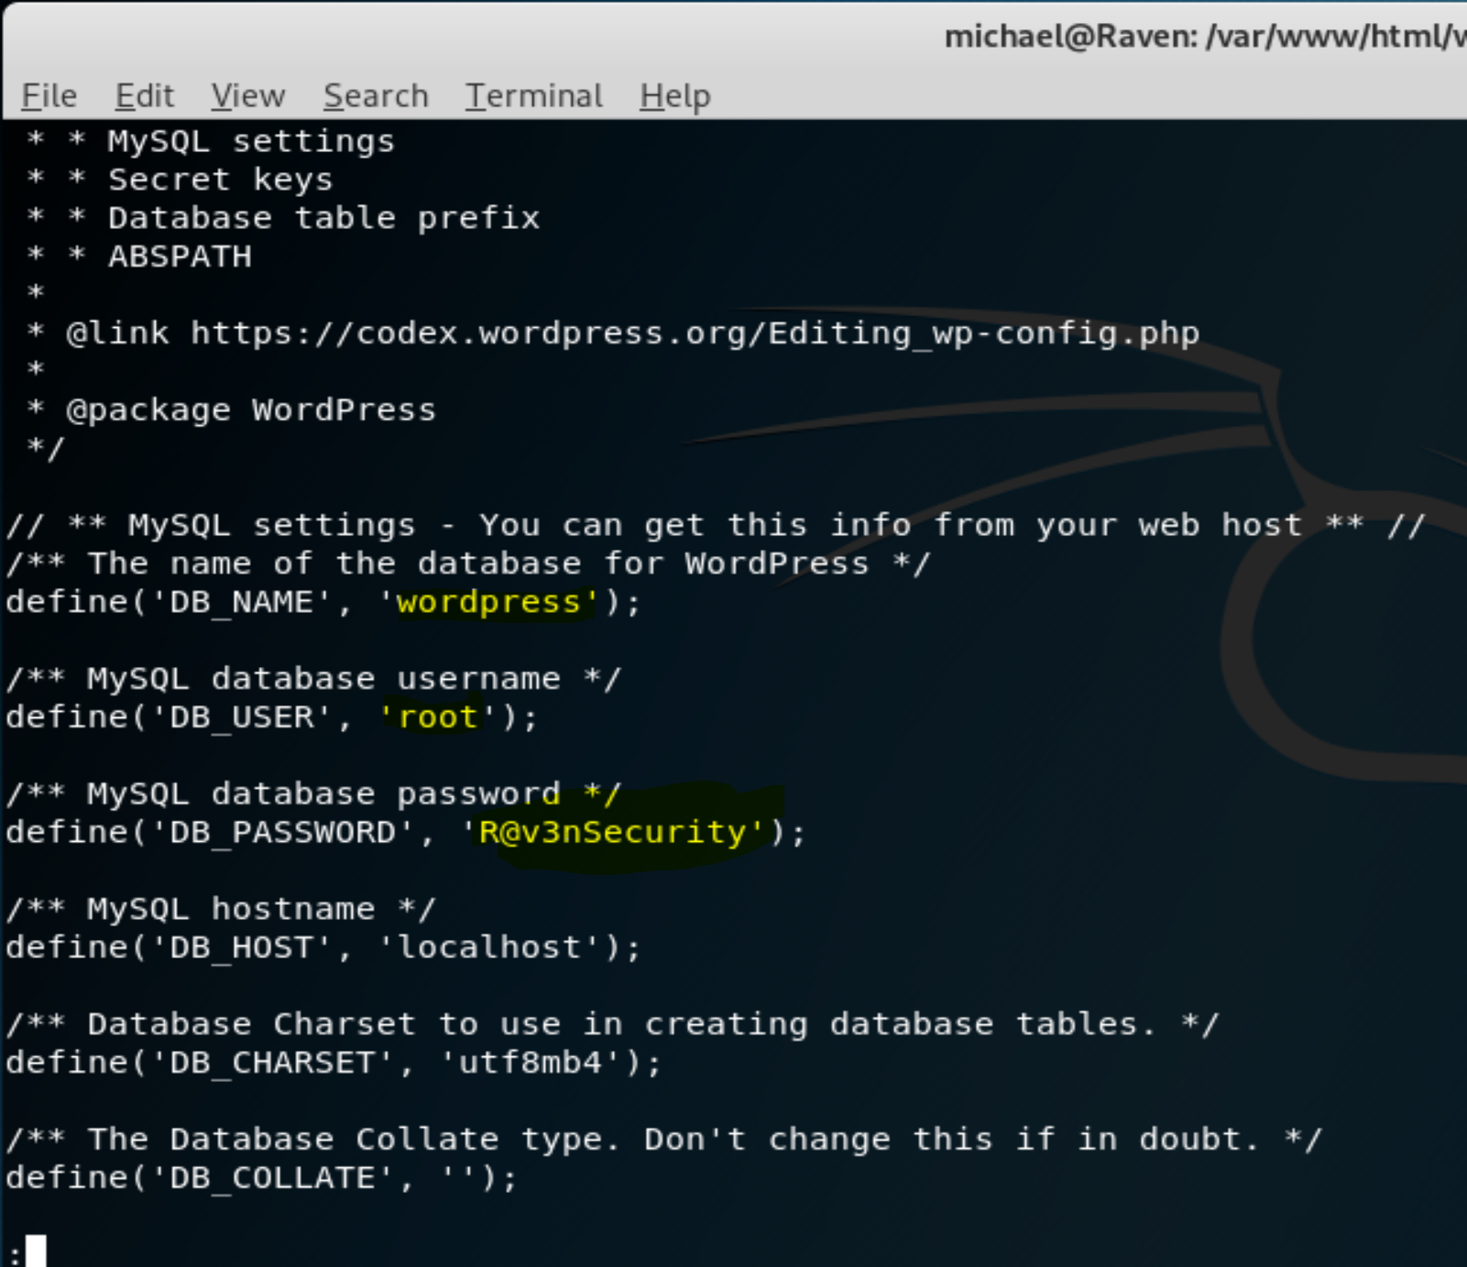

Now that we have root access the wordpress database, we dump tables that are useful for us(**wp**_**user table**). The table contains users steven and michael and their hashed passwords:

Steven: $P$Bk3VD9jsxx/loJoqNsURgHiaB23j7W/

michael: $P$BjRvZQ.VQcGZlDeiKToCQd.cPw5XCe0

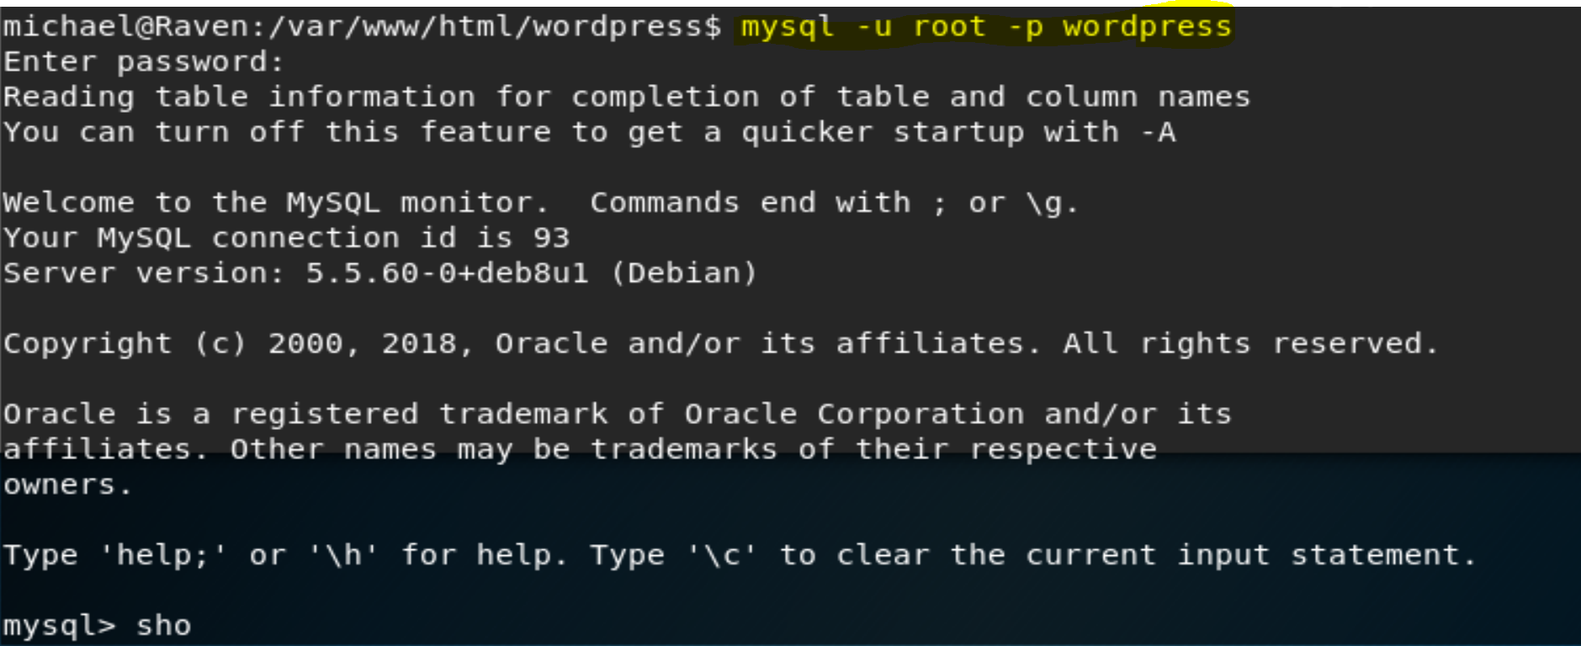

We can use john the ripper and get the password from the hash for user steven:

Wordpress credentials(ssh and wordpress happens to be the same): **steven:pink84**

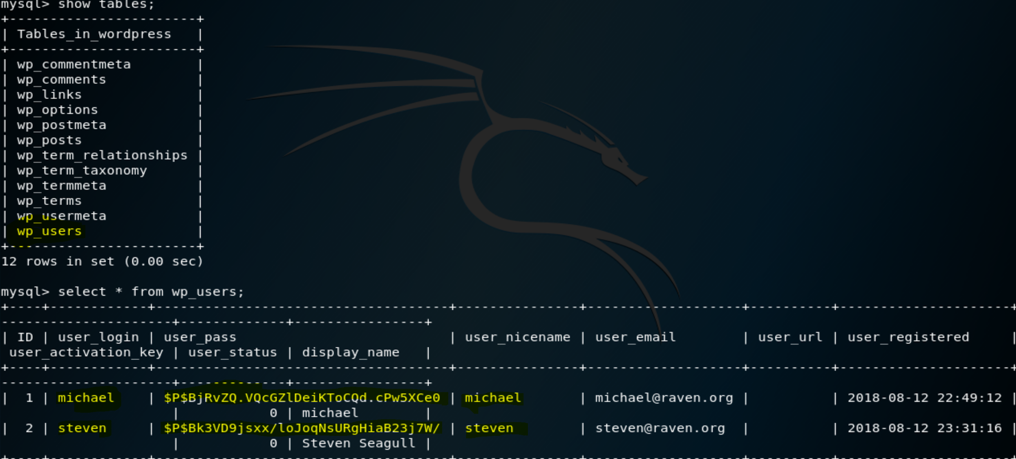

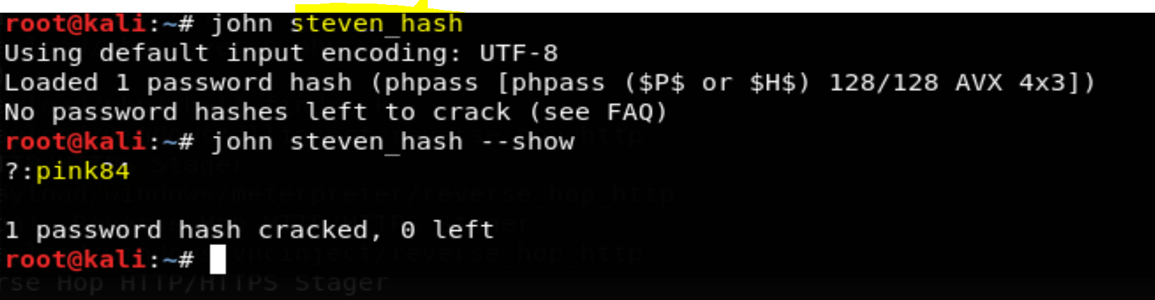

**Post-Exploitation Exploration and Privilege Escalation**

We able to escalate privilege to root due to misconfiguration by an admin for user steven. Steven had sudo privilege for Python. Giving sudo privilege to any programs/editors/interpreter(vim, vi, nano, nmap, etc)is a no no in linux. It is well know that with sudo privilege these programs are able to escape to root shell.

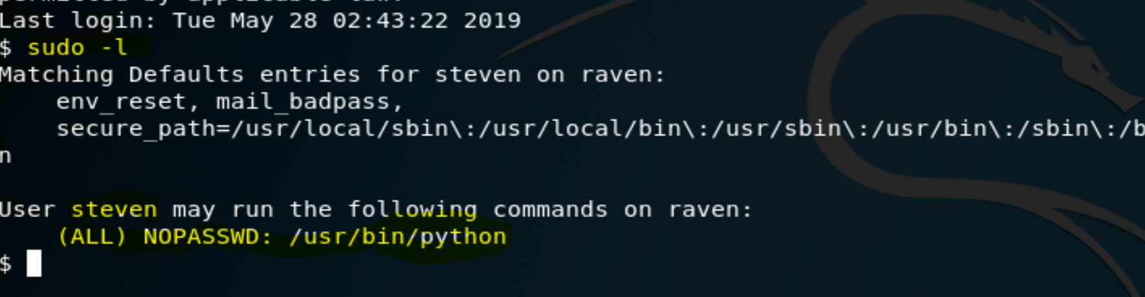

For our case we were able to escape to root shell with a few lines of Python code:

**sudo python**

**import os**

**os.system(‘/bin/bash’)**

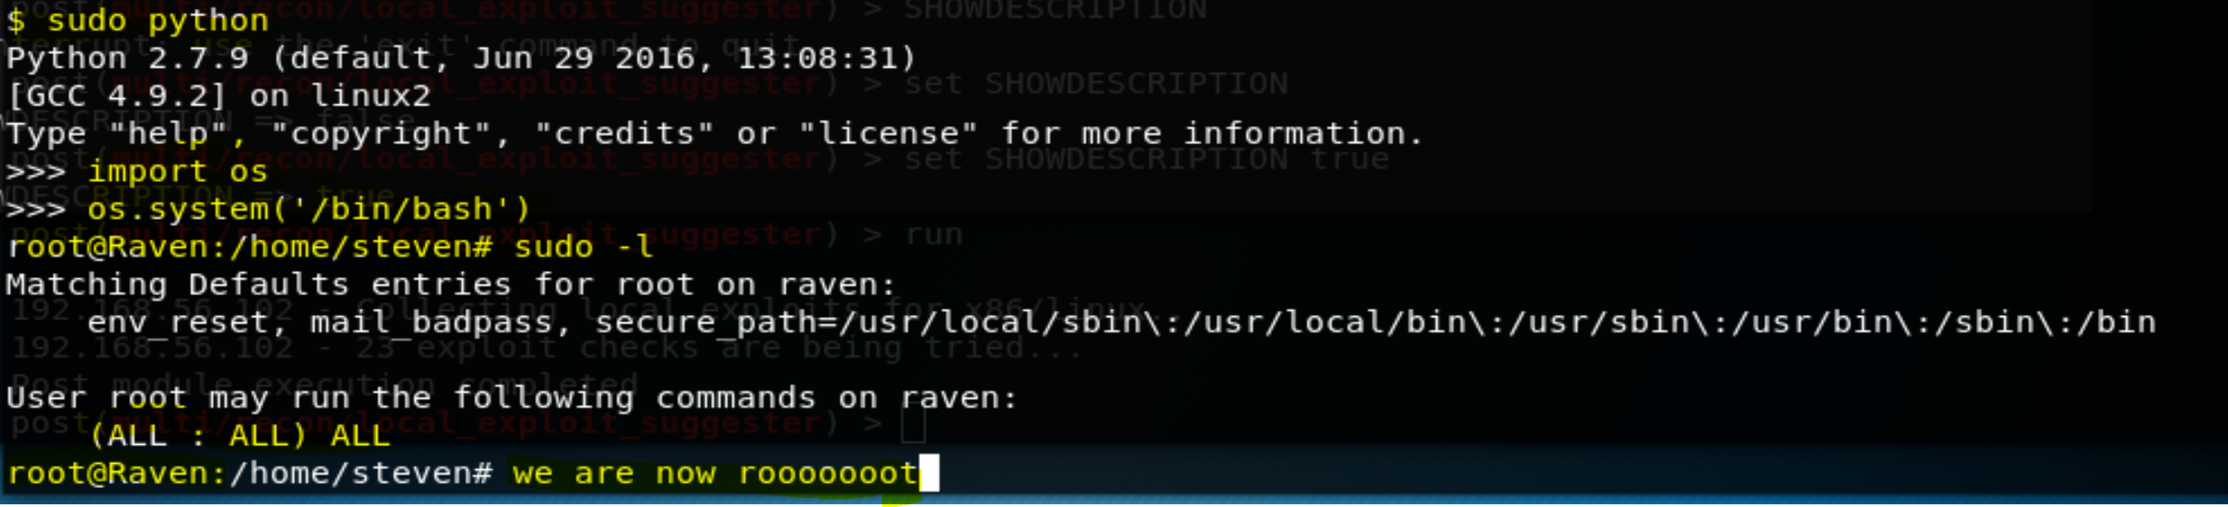

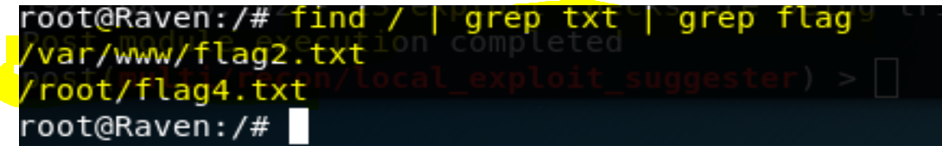

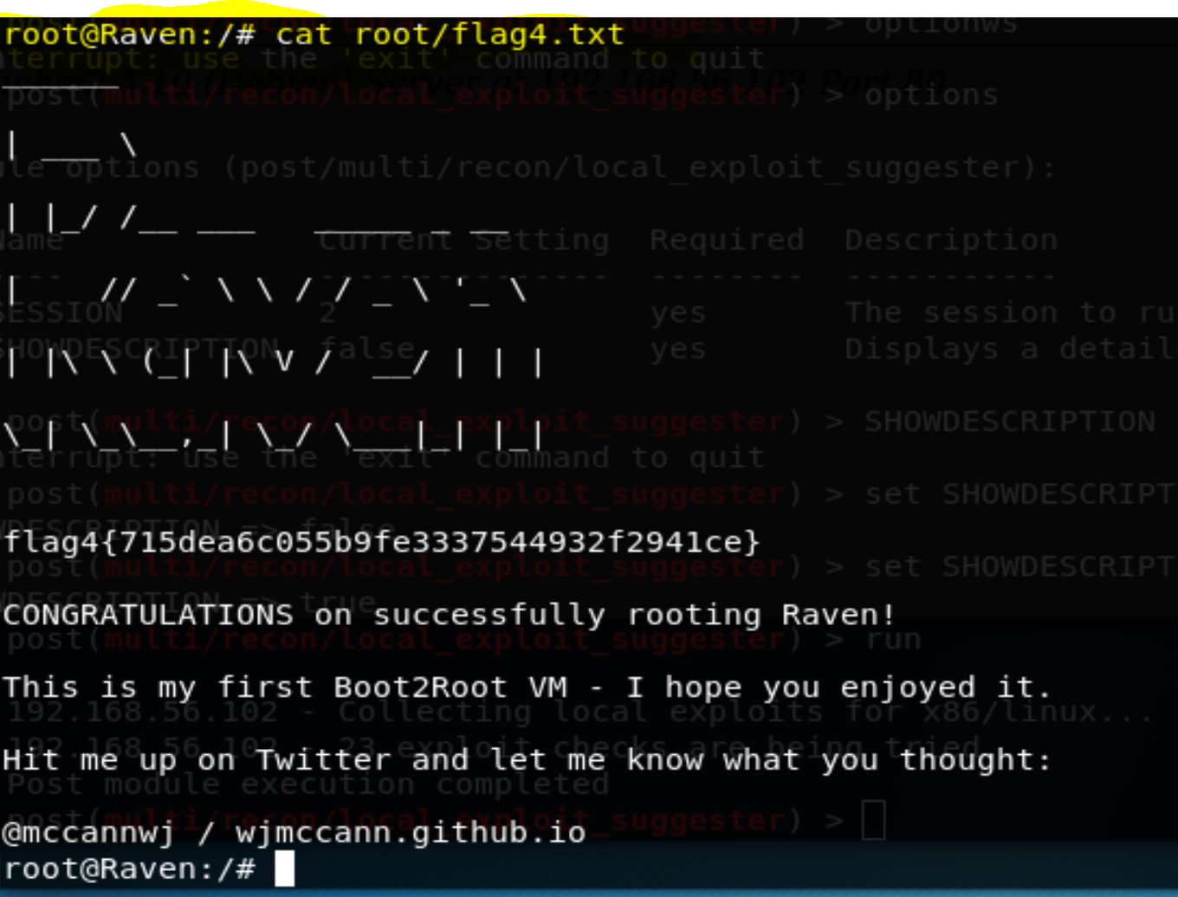

**Conclusion and Recommendations**

Based on the results documented above, we recommend the client take the following steps to remediate the vulnerabilities identified on the target machine.

**Web Server**

1. The MySQL login credentials, kept in wp-config.php, we on the web server itself. The file should be kept off the web server directory and in directory that only root/admin an access. The mysql login credentials can not be a root user. A separate mysql user should be created for the website, a user that only limited write/read to certains tables belonging specifically to the website only.
2. Create a new firewall rule that does not allow attackers brute force the website; limit the amount of attempts at login.
3. Update wordpress to the latest version, and if possible discontinue using wordpress and choose another web framework. There are many other web framework that have much better security.

**Network Services**

1. Update ssh to the latest version, and create a firewall rule that limits the amount of repeated attempt to login.
2. User password must be 8 characters long, include at least one special character, one number and a capitalized letter. The password being changed every 3 months.

**Hardening the Server**

1. Remove sudo privilege for Python from user steven.
2. Never give sudo privileges for all users not named root.